Basic Logic Gates Quiz

- What is the logic gate symbol for the NAND gate?
Circle one below.
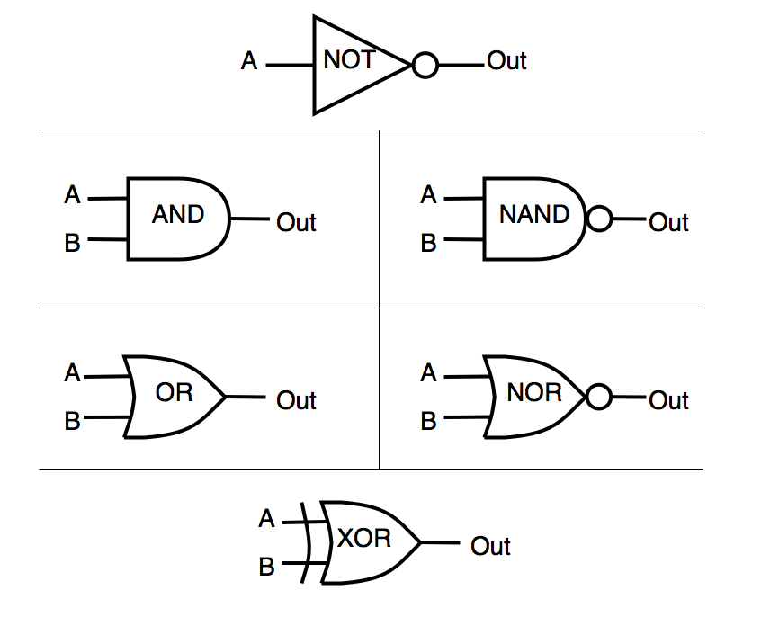

- Which logic gate symbol is this?

Answer: ___________________

- Which logic gate symbol is this?

Answer: ___________________

- Which logic gate corresponds to the truth table below?
A | B | X
0 | 0 | 1
0 | 1 | 1
1 | 0 | 1
1 | 1 | 0

Circle one logic gate:
A
B
A
B
A
B
x
x
A
B
x
A

x
x

Hint: The truth tables shows the logic gate output a 1, when both or either inputs are 0.

- Which logic gate corresponds to the truth table below?
A | B | X
0 | 0 | 0
0 | 1 | 0
1 | 0 | 0
1 | 1 | 1

Circle one logic gate:
A
B
A
B
A
B
x
x
A
B
x
A

x
x

Hint: The truth tables shows the logic gate output a 1, when both or either inputs are 1.

- Fill in the truth table for a NOT logic gate
A | X
0
1

- Fill in the truth table for a NOR logic gate
A | B | X
0 | 0
0 | 1
1 | 0
1 | 1

- Which logic gates inverts the output?

Answer: ___________________

- Fill in the missing word to complete the sentence.

The _______ gate outputs a 1 when both of its inputs is a 1 or both of its inputs is a 0.

- What is the Boolean expression for this logic gate?

Answer: ___________________

- What is the Boolean expression for this logic gate?

Answer: ___________________

